Calculating Shortest Path in QGIS
The QGIS Geoprocessing Toolbox has a set of network analysis tools that can calculate the shortest path from one point to another.
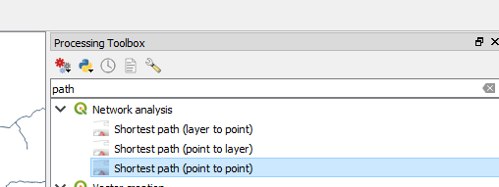

First you need to create or already have a vector layer containing the paths (e.g. your walking tracks, roads, valid paths around the campus). The simplest tool is Shortest path (point to point), in which you click on your start and end point.
There is a full tutorial here:
https://docs.qgis.org/3.4/en/docs/training_manual/vector_analysis/network_analysis.html

