Observing Coordinates on your phone with GPS Status
Step 1: Install and Set up App
  - Install the GPS Status app from Google play store (or equivalent in iPhones)

  - Go to Settings (touch anywhere on screen to make hamburger button appear, then touch to open menu).

  - Set accuracy units to metres.
Settings > Units and Formatting > Distance > meter,km

  - Set coordinate accuracy to decimal degrees.
Settings > Units and Formatting > Location format > DD.DDDDDD

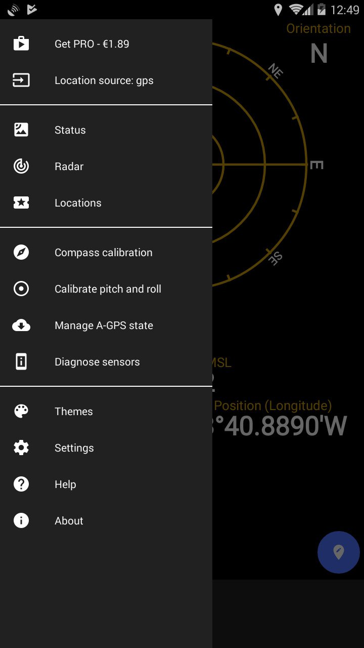

Step 2: Observe coordinates
Why?
- Stand as close as you can to the object (or put your phone on it).

- Let the accuracy of your GPS settle (watch it go down until it stabilises).

