Surface Modelling in QGIS
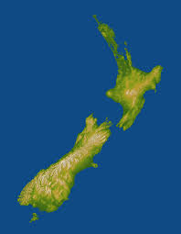
Surface modelling involves taking a series of points for which values are known, and creating a surface that can be represented in various ways. One common way is to shade the resulting surface based on elevation.
Surface modelling is commonly used to model the elevation of the earth, so higher areas are shaded a different colour than lower areas, and we can see on the 2D map something about the topography, or shape of the land. This map is a simple example. The lowest areas are green, the highest are lighter brown.

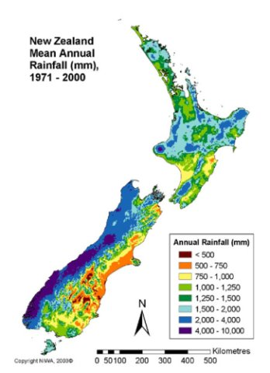
The same technique is often used to display some other variable that is geographically distributed. For example, this map shades the land by the level of rainfall.

You can create a surface model of the Massey campus showing any variable that you like, as long as you have some point values over the surface. The process involves performing interpolation, to fill in gaps so that it has enough points to make a surface. This tutorial creates a triangulated interpolated surface, which is one of the most common methods:
https://www.qgistutorials.com/en/docs/interpolating_point_data.html
The result is a raster layer, and you can then change the styles to display it in a way that suits your particular application, using the steps shown in the tutorial.

